Chapter 8
Cluster Randomized Trials

The Cluster Randomized Design
The hierarchical or cluster randomized design (which assigns all individuals within a block or cluster to the same treatment). In the terminology of experimental design, blocks or clusters are nested within treatments (see, e.g., Kirk, 1995).
This design arises, for example, when schools are blocks and entire classrooms (all the individuals within a classroom) are assigned to the same treatment. One can conceive the sampling of individuals as a two-stage cluster sample. Clusters (e.g., schools) are considered to have random effects. This idea might seem counterintuitive, particularly if all of the schools within a district are actually part of the experiment. The logic is similar to that of considering students to have random effects, even though we sample all of the students in the school, namely that we wish to make a statistical inference about the school, not just the particular students that happen to be in the school on this occasion. In making this inference, we imagine an inference across many samples of students that might have been sampled into the school.
The fact that schools must be considered to have random effects in the cluster randomized design is a weakness in development studies where the inference goal is to determine whether the treatment can have an effect under favorable circumstances. Other designs (e.g., randomized block designs) can capitalize on their ability to consider schools as having fixed effects to obtain greater design sensitivity for the same sample size. Yet there are sometimes practical reasons that a cluster randomized design is the only alternative. For example, when the intervention cannot be administered to a subset of the school for theoretical reasons (e.g., whole school interventions), political reasons (e.g., a highly desirable intervention), or practical reasons.

Layout of the Design
The term “block” (sometimes called plot, rather than a cluster) in experimental design comes from the origin of experimental designs in agriculture, where field experiments were literally conduced in agricultural fields and blocks or plots were literally plots of ground within those fields. The layout of the design is a diagram of how the field might be divided into plots within those fields. Figure 1 illustrates the layout of a cluster randomized design, with shaded areas corresponding to treated blocks and unshaded areas corresponding to control blocks. Note that the spaces between the blocks are intended to convey that the blocks (plots of land) might be physically distant from one another to ensure independence.
Insert Figure 1 About Here
In agriculture, there are variations in outcomes due to micro-variations in characteristics such as soil fertility, drainage, and temperature. These characteristics are related physical proximity and the physical proximity of the points where observations are taken within blocks assures that observations within blocks are likely to be more similar than they are to observations from different blocks. Thus, observations within blocks are matched to one another.
In an educational field study, the ideas of layout and blocks are metaphorical rather than physical, but the same concept of matching applies. Individuals within blocks (e.g., schools) are likely to be more similar than individuals in different blocks. Thus assignment of clusters to treatments within blocks is a kind of assignment among individuals who are matched to one another by virtue of being in the same school.

Statistical Model and Notation
Suppose that the design has 2m blocks with n individuals in each block, and m blocks are randomly assigned to each of the treatment and the control condition. Such a design is called a balanced design because there are equal numbers of clusters and individuals assigned to each treatment. Balanced designs are desirable because they are the most sensitive, that is they produce statistical tests that have the highest statistical power and the most precise estimate of treatment effects for a given total sample size. Then, in the conventional notation of the analysis of variance, the model for Y_{ijk}, the outcome measurement of the k^{th} individual in the j^{th} cluster in the i^{th} treatment, is
Y_{ijk} = μ + α_{i} + β_{j(i)} + ε_{ijk}, i = 1, 2; j = 1, …, m; k = 1, …, n; l = 1, …, n, (1)
where μ is the grand mean, α_{i} is the effect of the i^{th} treatment, β_{j(i)} is the effect of the j^{th} cluster within the i^{th} treatment, and ε_{ijk} is a residual. The residual ε_{ijk} is assumed to have a normal distribution with variance σ_{ε}² and the grand mean μ and the treatment effects α_{i} are taken to be fixed, but unknown constants.
In this design, β_{j(i)} is the effect of the j^{th} cluster within the i^{th} treatment. It therefore has a random effect, which has variance σ_{C}². It is conventional to define the effect size as the standardized mean difference
,
(see, Hedges, 2007).
Let(j = 1, …, m) and(j = 1, …, m) be the means of the j^{th} treatment and control group clusters, respectively, letand be the overall (group) means in the treatment and control groups, respectively, and letbe the grand mean. This notation with dots in the subscripts may seem confusing, but it has a logic. It takes the values of all four subscripts to identify a particular observation, but one could average over all observations in treatment group 1 to obtain (here that average is denoted by dots in the second and third subscripts which identify the cluster and individual within block and treatment combination within treatment group to denote averaging over individuals and clusters).

What Contributes to Uncertainty of the Treatment Effect in the Cluster Randomized Design
Precision of treatment effect estimates is best understood in terms of what counts as “error” or imprecision. Imprecision is all the variation within treatment groups. This is the “noise” that statistical tests compare to the signal of treatment effects to see if the treatment effects are big enough to be reliable (i.e., statistically significant). Because we assign individuals to treatments within clusters, variation across clusters is part of the imprecision of the treatment effect. Although it may be somewhat counterintuitive, in a balanced design, the precision of the estimated treatment effect computed from the 2mn individuals is exactly the same as the precision of the treatment effect computed from the 2m cluster means (much smaller number of “observations”).

The Statistical Analysis of the Design

In the analysis of this design, the overall treatment effect estimate is
and if (as in our model) the design is balanced
.
The test statistic used for testing treatment effects is
F = MST/MSCT,
where MST is the so-called treatment mean square defined by
,
and MSCT is the so-called clusters-within-treatment mean square defined by
(see, e.g., Kirk, 1995). When the null hypothesis of no treatment effects is true, the test statistic has the F-distribution with 1 degree of freedom in the numerator and 2(m – 1) degrees of freedom in the denominator. Thus we carry out the significance test by comparing the obtained value of F with the appropriate critical value of the F-distribution with 1 and 2(m – 1) degrees of freedom or by using the p-value computed by the analysis software.
The standard error (precision) of the treatment effect estimate is
.

Planning Cluster Randomized Designs

The object planning a research design is to ensure that if the data is collected according to the design, the analysis of that data will yield unambiguous results. To ensure results will be unambiguous, the design must be sufficiently sensitive. There are three different, but complementary, ways to describe design sensitivity, all of which can be useful in planning designs.
One way to describe design sensitivity is statistical power. Statistical power is the chance that if there is a (true or underlying) intervention effect of a given size, the statistical analysis is likely to detect it. Statistical power analysis starts with the size of an effect that is deemed important enough to detect, and a design (e.g., a sample size configuration), and describes the probability that an effect of the given size would result in a statistically significant observed effect. Computation of statistical power can be accomplished by suing tables of power values, but is more easily accomplished using specialized software
Another way to describe design sensitivity is the use of minimal detectable effect size. The minimal detectable effect size is the smallest effect size for which the design has a given statistical power. Using this approach, one starts with design (a sample size configuration) and a desired level of statistical power and describes the smallest effect size for which the design has the specified level of statistical power. Approximate computations of minimum detectable effect size can be done using tables, but exact computations of require specialized software.
A third way to describe design sensitivity is precision. Precision is the standard error of the estimated treatment effect, which determines the width of the confidence interval for the treatment effect. Using precision analysis, one starts with the design (a sample size configuration) and computes the precision that would be expected.

Design Sensitivity is a Function of m, n, and δ
Design sensitivity minimum detectable effect size and precision depend on the significance level chosen, the effect size expected, the cluster-within-treatment intraclass correlation ρ, m, and n. Statistical power depends, in addition, on the effect size δ. Design sensitivity values for ρ = 0.05 (typical values) a few m, n, and δ values are given in Table 1. Table 1 shows some general patterns of design sensitivity for various combinations of m and n that yield a fixed total sample size of N = 400 and effect size values of δ = 0.20, 0.35, and 0.50. There are three horizontal panels in the table, each panel has the same effect size δ and shows the statistical power, minimum detectable effect size, and standard error of the estimated treatment effect for different configurations of m and n. Looking within each panel, note that each measure of design sensitivity depends strongly on m (for a fixed N), with power increasing and MDES decreasing as m increases. Comparing the corresponding rows of the three panels, note that statistical power increases as effect size increases, but MDES and precision (SE) depend only on m and n but are unchanged. That is because they are not predicated by any particular δ and thus do not depend on δ.

Insert Table 1 About Here

Design sensitivity also depends strongly on the intraclass correlation ρ. Appendix Table A1 presents design sensitivity values for the same combinations of m, n, and δ, but when ρ = 0.10. Comparing the corresponding values of the two tables, note that designs are less sensitive (power is smaller, MDES is larger and estimates of treatment effect are less precise, that is SE is larger, when ρ = 0.10 than when ρ = 0.05).

General Principles for Planning Cluster Randomized Designs
Planning a randomized block design with fixed block effects to evaluate an educational intervention primarily involves choosing a design that will have adequate sensitivity (high statistical power and precision, or small minimal detectable effect size). In principle, design sensitivity depends on the significance level chosen, the effect size expected, the classroom-within-school intraclass correlation ρ, m, and n. We call these three parameters design parameters because they essentially determine the design.
Although significance level is in principle an arbitrary choice of the investigator, the 0.05 or 5% significance level has been so reified by convention that it is, for all practical purposes, not a choice but the de facto standard. The effect size expected is also not completely a choice but is dictated by the prior experience of the investigator about what size effect is large enough to be important or is the effect size to be expected from the intervention being evaluated. The intraclass correlation can be influenced by the investigator. Thus, planning the design amounts to minimize the intraclass correlation ρ and deciding on how many blocks or sites (which are typically schools), to assign to each treatment within each block, and how many subjects (usually students) n to choose to compose each cluster. That is, planning the design involves minimizing ρ and choosing m and n to achieve the desired design sensitivity.
The computation of either statistical power or minimum detectable effect size can be accomplished by using statistical tables that are widely available (see, e.g., Hedges and Rhoads, 2009) or by the use of statistical software that can compute noncentral F-distribution function (see the Appendix). It is probably easiest to use software that is designed to do the computations directly (e.g., Website reference). However, caution is necessary in using software, particularly for complex designs like this one, because notation and terminology differ among software packages and the same terms (e.g., “effect size” do not mean the same things for all software packages, see, Spybrook, Hedges, and Borenstein, 2014). While exact power computations using software are recommended, the relations between m, n, and ρ with design sensitivity are rather complex. In the sections that follow, we offer a few general principles that are helpful in planning designs and illustrate them with computations of design sensitivity.

The Classroom-Within-School Intraclass Correlation
Design sensitivity depends strongly on the intraclass correlation: The smaller the intraclass correlation, the higher the design sensitivity. The classroom-within-school intraclass correlation ρ is defined as the variance of the classroom means σ_{C}² divided by the total variation of outcome observations (Y_{ijk} scores) across clusters (schools), that is
ρ = σ_{C}²/( σ_{C}² + σ_{ε}²).
If the schools are simply sampled, then ρ is determined by the natural distribution of school means. This distribution will be determined partly by the distribution of scores and by policies that determine how students are allocated into schools. For example, if schools were a diverse mix of some with higher and other with lower SES student bodies and therefore academic achievement would be expected to have high intraclass correlations.
Empirical evidence suggest that typical school level intraclass correlations across a range of schools are on the order of 0.2 nationally, and tend to be smaller (on the order of 0.1) in high socio-economic status schools than in lower SES schools (see, e.g., Nye, Konstantopoulos, and Hedges, 2004). There is also empirical evidence that the intraclass correlations within school districts is often smaller. For example, Hedberg and Hedges (2014) found that the mean intraclass correlation within medium sized elementary school districts was often less than 0.05.
It is possible to influence ρ when designing an experiment by matching the group of schools to be assigned before random assignment to treatments. If a pretest X is available, it may be possible to select schools that have very similar average pretest scores to be the experimental sample. Such pretest data at the school aggregate level is often available from administrative records or on state websites. If individual level data is available, it may be possible to compose the experimental sample by selecting a subset of individuals from each school whose mean pretest scores match closely across schools.
It is generally not possible to make ρ = 0 because matching is carried out on pretest scores, but the intraclass correlation of interest is defined in terms of the between- and within-school variances of the outcome (posttest) scores. If the pretest-posttest correlation is ρ_{Y\X} then the variance of school mean scores on the outcome Y for a given pretest value X is
(1 – ρ_{Y\X}²)σ_{ε}²/n.
Therefore, if all the school means matched exactly on the pretest X, the intraclass correlation would be
.
For example, if ρ_{Y\X}² = 0.5 (so that ρ_{Y\X} ≈ 0.71) and n = 20, then ρ ≈ 0.02. It is important that the ρ value obtained after matching depends on n, so that is n is smaller, ρ becomes larger. For example, if ρ_{Y\X}² = 0.5 but n = 50, then ρ = 0.01, and if n = 100, ρ = 0.005. Thus, the impact of the within cluster sample size n on ρ will need to be considered in selecting the appropriate n for the design.
If the outcome variable and pretest are cognitive tests like achievement tests, a pretest-posttest correlation of ρ_{Y\X} ≈ 0.7 is quite sensible, and hence it should be possible to obtain an intraclass correlation of ρ = 0.01 to 0.05. Empirical evidence suggests that background variables like race, gender, and crude social class indicators (like free or reduced-price lunch eligibility) will have correlations with outcomes and thus even perfect matching on such covariates will lead larger intraclass correlations (see Hedges and Hedberg, 2007). In other words, matching on a covariate that is a pretest is strongly recommended.

The Number m of Schools Will be Limited in Development Studies
Perhaps the most stringent limit in initial field trials in development studies is that it is usually infeasible to involve large numbers of schools. Thus, the number of schools is usually limited to 5 to 10, an occasionally as many as 20. Because the total number of schools is 2m, this means that m = 5 – 10 is about the maximum that is likely to be feasible. Thus, even though sensitivity depends strongly on m, and it is important to obtain as large a number of schools as feasible, there are usually practical limits on how much m can be used to increase design sensitivity.

Increasing Cluster Size n Can Increase Design Sensitivity if ρ is Relatively Small
While there are typically sharp limits on the number of schools, it is often feasible to obtain a lager number of students in each school (for example, several classrooms). The relation between n and design sensitivity is complex. Design sensitivity increases with n, but begins to level off so that it tends to an asymptote. The asymptote depends on the intraclass correlation ρ, being smaller when ρ is larger. Thus, it can be impossible to obtain adequate sensitivity for some m and ρ regardless of how large n (or the total sample size) becomes. Table 2 presents the smallest possible MDES as a function of m and ρ. Two general patterns are evident. As m increases, the smallest possible MDES decreases and as ρ increases the minimum MDES increases. For example, if ρ = 0.05, the minimum MDES decreases from 1.27 when m = 2 to 0.30 when m = 10. Similarly, for m = 5, the minimum MDES increases from 0.20 when ρ = 0.01 to 0.64 when ρ = 0.10. This table makes clear that for values of m that are often feasible in development studies (m ≤ 10), it is important to ensure that ρ is as small as possible in order to have adequate design sensitivity to detect the effect sizes that are plausible (e.g., δ ≤ 0.5).

Insert Table 2 About Here
The values in table 2 illustrate what design sensitivities are possible with large enough n, but do not indicate what specific values of n would be required to have any particular design sensitivity. Table 3 presents minimum detectable effect size as a function of m and n when ρ = 0.05. For example, the table shows that when m = 5, the MDES < 0.50 for n ≥ 100 and when m = 8, MDES ≤ 0.35 when n ≥ 200. Note that MDES decreases rapidly as n increases when n is small (e.g., n = 10 – 20), but MDES decreases very little as n increases when n is large (e.g., 100 – 200). Appendix table A2 gives the minimum detectable effect size as a function of m and n when ρ = 0.02. That table shows that the MDES is considerably smaller if ρ can be made as small as 0.02. In this case when m = 5, the MDES ≤ 0.35 for n ≥ 100 and when m = 8, MDES ≤ 0.25 when n ≥ 200. It is important to note that very stringent matching before randomization is required to obtain an intraclass correlation of ρ = 0.02. Appendix table A3 gives the minimum detectable effect size as a function of m and n when ρ = 0.075. That table shows that the MDES is considerably when ρ becomes larger, illustrating the importance of careful matching to reduce the intraclass correlation.

Insert Table 3 About Here

Unbalanced Designs May Be a Feasible Way to Increase Design Sensitivity
For a fixed total sample size, a balanced design (equal allocation of individuals to treatment and control in each block) is the most sensitive. However, there are situations in which the sample size is limited by the number of schools that can be treated (e.g., because of limitations of personnel needed for training or implementation or of equipment). In that case, unequal allocation of schools to treatment groups (more classes randomized to treatment and fewer to control or vice versa) can increase the total sample size of schools and can increase design sensitivity. For example, if only one third of the schools willing to participate in the experiment can be treated, allocating only one-third of the schools to treatment and two-thirds of the schools to control makes it possible to obtain an overall school sample size that is 50% larger. Although it might seem counterintuitive, the design sensitivity is the same regardless of whether there are more treatment or more control schools.
Suppose that an unbalanced design assigns m^{T} clusters (classes) to treatment and m^{C} clusters (classes) to control in each block so that the proportion π = m^{T}/(m^{T} + m^{C}) of clusters are assigned to treatment and a total of N^{T} = Nπ individuals are assigned to treatment overall. In a balanced design the total sample size would be N = nm^{T}/0.5 = 2nm^{T}, but in an unbalanced design, because π < 0.5, the total sample size N would be greater than 2nm^{T}. In fact, the ratio of the total sample size of a design with π = N^{T}/N to that of the balance design would be 1/2π. Thus if π = 0.5 (the design is balanced) the ratio is unity, as expected, but if π = 1/3, the total sample size of the design is 50% larger, if π = 1/4 it is 100% larger than that of a balanced design with the same number of treated individuals. This increased total sample size increases design sensitivity.
While imbalance of the design does not literally change the effect size, it has an effect on sensitivity that is equivalent of changing the effect size from δ to. Because
and is only equal to δ if π = 0.5, imbalance has a tendency to increase sensitivity because of the increased total sample size, but a simultaneous tendency to decrease sensitivity because it does the equivalent of decreasing the effect size. However, unless π is very much smaller than 0.5, the positive impact of imbalance on total sample size is bigger than the negative impact on effect size and the unbalanced design is more sensitive with the same number of treated individuals.

Table 4 shows the minimum detectable effect size as a function of the number of treatment clusters m^{T} and the number of the number of control clusters m^{C} with n = 50 individuals per cluster when ρ = 0.05. The table shows m^{C} ≥ m^{T}, but the MDES is identical for the corresponding pairs of m^{T} and m^{C} if m^{T} ≥ m^{C}. For example, the table shows that an unbalanced design with m^{T} = 4 and m^{C} = 4 + 4 = 8 (and a total sample size of N = 600) would have a minimum detectable effect size of δ = 0.50, but table 4 shows that a balanced design with the same number of treated clusters ρ = 0.05, m^{T} = m^{C} = 4, and n = 75, (with the same total sample size of N = 600) would have an MDES of δ = 0.60. In other words, the unbalanced design achieves greater design sensitivity with the same number of treatment clusters and the same total sample size but it requires a larger number of control clusters. Appendix tables A4 and A5 show the minimum detectable effect size as a function of m^{T} and m^{C} when ρ = 0.05 and n = 75 or n = 100, respectively.

Insert Table 4 About Here

Statistical Adjustment for Covariates Can Substitute for Matching of Classes
Covariates are any variables whose value could not have been influenced by the treatment assignment. The most common covariates are baseline data (such as pretests) collected before the treatment begins. If baseline data on schools is available, it can be used to increase the sensitivity of the design if the analysis uses statistical adjustment via regression or the analysis of covariance. In a design such as this, covariates primarily increase design sensitivity by reducing between-cluster (between-school) variation in outcome scores. The use of a covariate (or multiple covariates) essentially has the same impact as matching and there is no additional benefit to using covariates in the analysis if the classes have been matched on the covariate prior to assignment to treatment. Moreover, using a covariate at the cluster level reduces the degrees of freedom available in the error term, which has a tendency to reduce statistical power. Therefore, although statistical adjustment with a pretest or other covariates could be considered as an alternative to matching, it may not be as helpful as matching when the total number of clusters is very small (less than 15).

Examples

Conclusions

References
Bloom, H. S. (1995). Minimum detectable effects: A simple way to report the statistical power of experimental designs. Evaluation Review, 19, 547-556.
Hedberg, E. C., & Hedges, L. V. (2014). Reference values of intraclass correlations of academic achievement by district characteristics. Evaluation Review, 38, 546-582.
Hedges, L. V., & Borenstein, M. (2014). Conditional optimal design in three and four-level experiments. Journal of Educational and Behavioral Statistics, 39(4), 257-281.
Hedges, L. V. & Hedberg, E. C. (2007). Intraclass correlations for planning group-randomized experiments in education. Educational Evaluation and Policy Analysis, 29, 60-87.
Hedges, L. V. and Rhoads, C. (2009). Statistical Power Analysis in Education Research (NCSER 2010-3006). Washington, DC: National Center for Special Education Research, Institute of Education Sciences, U.S. Department of Education.
Kirk, R. (1995). Experimental design (3rd Edition). Belmont, CA: Brooks Cole.
Searle, S. R. (1971). Linear models. New York: John Wiley.
Spybrook, J., Hedges, L. V., & Borenstein, M. (2014). Understanding Statistical Power in Cluster Randomized Trials: Challenges Posed by Differences in Notation and Terminology. Journal of Research on Educational Effectiveness, 7(4), 384-406.

Appendix

The following tables provide additional information about minimal detectable effect sizes for planning designs.

Insert Appendix Tables A1 – A5 About Here

Power Computations
Power computations for this design are based on the sampling distribution of the F-statistic given in the text. When there is no block treatment interaction and δ² ≠ 0, then F has the
noncentral F-distribution with m^{T} + m^{C} – 2 degrees of freedom and noncentrality parameter
(see, e.g., Searle, 1971). Therefore, the statistical power of the level α test of the null hypothesis H₀: δ² = 0 is
G[c_{α}| λ, m^{T} + m^{C} – 2]
where c_{α} is the 100(1 – α) percentile of the central F-distribution with m^{T} + m^{C} – 2 degrees of freedom and G[x | λ, ν] is the cumulative distribution function of the noncentral F-distribution with ν degrees of freedom and noncentrality parameter λ.
The limiting power as n tends to infinity (for fixed m^{T} and m^{C}) is obtained by noting that λ tends to
.
Because power is a continuous function of λ, the limiting power is the power when λ = λ_{max}.
The approximate minimal detectable effect size can be obtained using a formulas in Bloom (1995) or by iteratively computing power with successively larger values of the effect size until the appropriate power is obtained.

Figure 2
Minimum detectable effect size as a function of m for p = 2, ρ = 0.05, and n = 10 (dashed line),
n = 12 (dotted line), n = 15 (dashed and dotted line), and n = 20 (long dashed line)

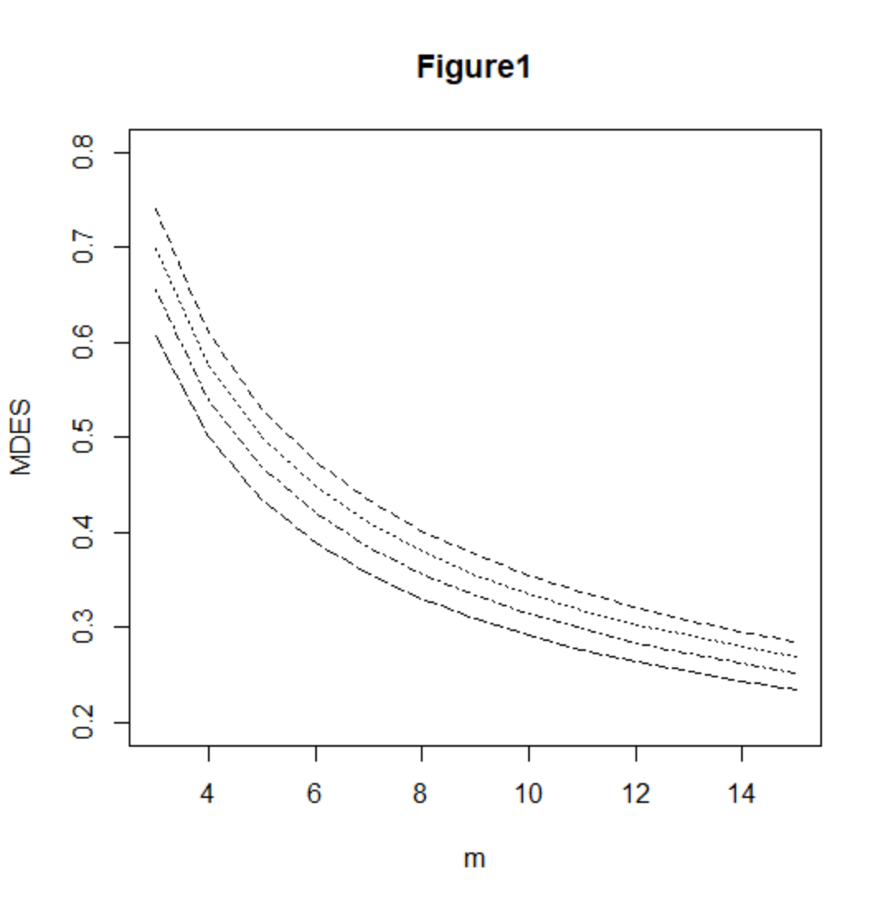

Figure 3
Minimum detectable effect size as a function of m for p = 3, ρ = 0.05, and n = 10 (dashed line), n = 12 (dotted line), n = 15 (dashed and dotted line), and n = 20 (long dashed line)

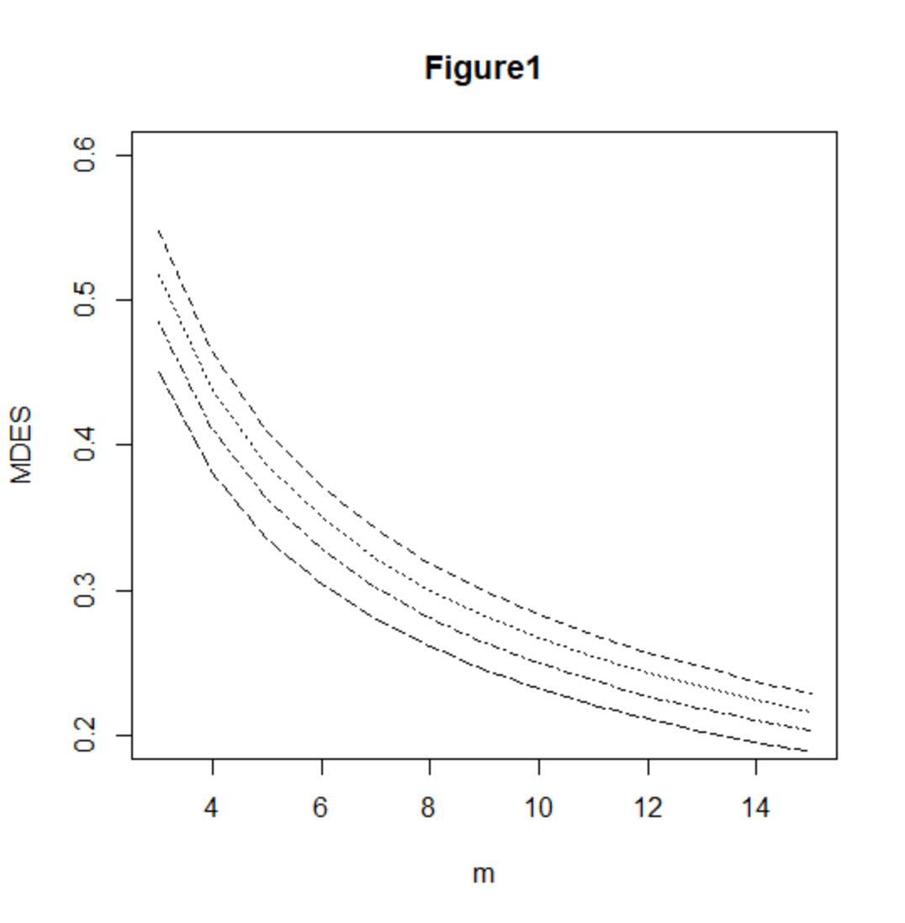zz

